PROJECT REPORT
Implement Client Script & UI Policy (Incident)
ServiceNow | Incident Management | UI Policy | Client Scripts | Form Validation
Team ID: [Enter Team ID]
Team Members: [Enter names and roles]
Date: 13 October 2026

Table of Contents
1. Introduction
2. Ideation Phase
3. Requirement Analysis
4. Project Design
5. Project Planning & Scheduling
6. Functional and Performance Testing
7. Results
8. Advantages & Disadvantages
9. Conclusion
10. Future Scope
11. Appendix

1. Introduction

1.1 Project Overview
Incident records need consistent and accurate data entry so that triage, routing and resolution work well. Relying only on user awareness and manual checks leads to incomplete or incorrect data, which hurts reporting accuracy and SLA compliance.
This project uses ServiceNow client-side controls (UI Policies and Client Scripts) on the Incident table to enforce data integrity directly on the form. When an Incident has High impact, the form makes Assignment group mandatory, locks Urgency, auto-sets Urgency to High, blocks saving when Assigned To is empty, and blocks State edits from the list view.

1.2 Purpose
- Demonstrate conditional field behaviour (mandatory, read-only) using UI Policy and UI Policy Actions.
- Automate field values with an onChange Client Script.
- Prevent invalid submissions with an onSubmit Client Script.
- Restrict direct list edits with an onCellEdit Client Script.
- Ensure Incidents are created with complete and valid information, improving data quality across the platform.

2. Ideation Phase

2.1 Problem Statement
Date | 13 October 2026
Team ID | [Enter Team ID]
Project Name | Implement Client Script & UI Policy (Incident)
Maximum Marks | 2 Marks

Customer Problem Statement (template format):
Problem Statement (PS) | I am (Customer) | I'm trying to | But | Because | Which makes me feel
PS-1 | A service desk agent / ITSM administrator | Log and route High-impact Incidents quickly and correctly | Incidents are saved without an Assignment group or Assigned To | Nothing on the form forces these fields to be filled when impact is High | Frustrated, because critical tickets stall and SLAs are at risk
PS-2 | A service desk manager | Keep Incident data consistent for reporting | Urgency is changed manually and State is edited from list view | There are no controls on field behaviour or list editing | Worried about unreliable reports and bypassed process

2.2 Empathy Map Canvas
Date | 13 October 2026
Team ID | [Enter Team ID]
Project Name | Implement Client Script & UI Policy (Incident)
Maximum Marks | 4 Marks

Quadrant | Observations (Service Desk Agent / Admin)
Says | "This High-impact ticket has no owner."  "Why is the urgency different from the impact?"  "Who changed the State from the list?"
Thinks | Mandatory data should be enforced by the system, not by memory.  One missed field can delay a critical incident.
Does | Opens incidents, sets Impact, fills Assignment group / Assigned To.  Edits fields inline from the list to save time.
Feels | Pressure to resolve high-priority issues fast.  Frustrated by rework caused by incomplete tickets.
Pains | Incomplete or incorrect data, SLA breaches, inconsistent reports.
Gains | Clear, guided forms; automatic Urgency; confidence that data is valid before submit.

2.3 Brainstorming
Date | 13 October 2026
Team ID | [Enter Team ID]
Project Name | Implement Client Script & UI Policy (Incident)
Maximum Marks | 4 Marks

Step 1: Team gathering and problem selection
The team selected PS-1: High-impact Incidents are being saved with missing ownership and inconsistent urgency.

Step 2: Idea listing and grouping
Group | Ideas
Conditional field behaviour | Make Assignment group mandatory when Impact = High  Make Urgency read-only when Impact = High  Reverse the behaviour when Impact is changed
Automation | Auto-set Urgency to 1 - High when Impact = 1 - High  Show an info message to the user
Save-time validation | Block submit if Assigned To is empty on High impact  Show an inline error on the field
List-view control | Block State changes made via list editing  Direct users to open the Incident form

Step 3: Idea prioritisation
Idea | Impact | Effort | Decision
UI Policy: Assignment group mandatory + Urgency read-only | High | Low | Implement (Sprint-1)
onChange script: auto-set Urgency | High | Low | Implement (Sprint-1)
onSubmit script: Assigned To validation | High | Low | Implement (Sprint-2)
onCellEdit script: block State list edit | Medium | Low | Implement (Sprint-2)

3. Requirement Analysis

3.1 Customer Journey Map
Stage | Create Incident | Set Impact = High | Save / Submit | Edit later
User action | Opens Incident > Create New | Selects 1 - High | Clicks Submit | Changes Impact or edits State in list
System response | Standard form loads | Assignment group becomes mandatory, Urgency set to High and locked | Blocked with an error if Assigned To is empty | Reverse-if-false unlocks Urgency; list edit of State is blocked
Experience | Neutral | Guided | Clear feedback on what is missing | Consistent, controlled
Opportunity | Add more templates | Extend to Priority-based rules | Add more validations | Add role-based exceptions

3.2 Solution Requirements
Date | 13 October 2026
Team ID | [Enter Team ID]
Project Name | Implement Client Script & UI Policy (Incident)
Maximum Marks | 4 Marks

Functional Requirements
FR No. | Functional Requirement (Epic) | Sub Requirement (Story / Sub-Task)
FR-1 | UI Policy: High Impact Control | Create UI Policy on Incident with condition Impact is 1 - High  Enable Reverse if false
FR-2 | UI Policy Actions | Assignment group: Mandatory = True  Urgency: Read-only = True
FR-3 | onChange Client Script | Run when Impact changes  Set Urgency to 1 and show info message
FR-4 | onSubmit Client Script | Block save when Impact = 1 and Assigned To is empty  Show error on Assigned To
FR-5 | onCellEdit Client Script | Block State edits from list view  Show alert directing user to the form
FR-6 | Testing | Mandatory enforcement, successful save, reverse condition, list-edit block, form-based update

Non-functional Requirements
NFR No. | Non-Functional Requirement | Description
NFR-1 | Usability | Clear messages and inline errors; no extra training needed.
NFR-2 | Security | Created and changed only by users with admin/configuration access; validations are enforced on the form.
NFR-3 | Reliability | Rules behave the same on every High-impact Incident; UI Policy reverses cleanly.
NFR-4 | Performance | Lightweight client-side logic; no server round-trips for the checks.
NFR-5 | Availability | Runs wherever the ServiceNow instance is available (platform-native).
NFR-6 | Scalability | Rules apply to all Incident records and can be extended to other tables.

3.3 Data Flow Diagram and User Stories
Date | 13 October 2026
Team ID | [Enter Team ID]
Project Name | Implement Client Script & UI Policy (Incident)
Maximum Marks | 4 Marks

Data flow (text form):
User (Service Desk Agent)
| opens Incident form / sets Impact
v
Incident Form (Browser)
|-- UI Policy "High Impact Control" -> Assignment group mandatory, Urgency read-only
|-- onChange (Impact) -> g_form.setValue('urgency','1')
|-- onSubmit -> validate Assigned To; return false / true
v (only if valid)
ServiceNow Server -> Incident table [incident]

Incident List View -> onCellEdit (State) -> alert + callback(false) -> no update

User Stories
User Type | Epic | USN | User Story / Task | Acceptance criteria | Priority | Rel.
Service Desk Agent | High Impact Control | USN-1 | As an agent, I must provide an Assignment group when Impact is High. | Field is mandatory; reverts when Impact is not High | High | S1
 |  | USN-2 | As an agent, I want Urgency locked for High impact. | Urgency is read-only | High | S1
 | Auto-set Urgency | USN-3 | As an agent, I want Urgency set to High automatically when I choose High impact. | Urgency = 1 - High with info message | High | S1
 | Save validation | USN-4 | As a manager, I want High-impact Incidents to have an owner before saving. | Save blocked with error on Assigned To | High | S2
Administrator | List control | USN-5 | As an admin, I want State edits blocked in list view. | Alert shown; State unchanged | Medium | S2

3.4 Technology Stack
Date | 13 October 2026
Team ID | [Enter Team ID]
Project Name | Implement Client Script & UI Policy (Incident)
Maximum Marks | 4 Marks

Table-1: Components and Technologies
S.No | Component | Description | Technology
1 | Platform | Low-code enterprise ITSM platform | ServiceNow (Personal Developer Instance)
2 | User Interface | Incident form and list views | ServiceNow Platform UI (Next Experience)
3 | Application Logic-1 | Conditional field behaviour | UI Policy and UI Policy Actions
4 | Application Logic-2 | Field automation, save validation, list-edit control | Client Scripts (onChange, onSubmit, onCellEdit) in JavaScript, using g_form
5 | Database | Incident records | ServiceNow table: incident
6 | Infrastructure | Hosted instance | ServiceNow cloud instance

Table-2: Application Characteristics
S.No | Characteristics | Description | Technology
1 | Open-Source Frameworks | None required; platform-native configuration | N/A
2 | Security Implementations | Config restricted to admin roles; scripts run in isolated scope | ServiceNow ACL / roles, Isolate script
3 | Scalable Architecture | Rules defined once on the table apply to all records | Table-level UI Policy and Client Scripts
4 | Availability | Inherits platform availability | ServiceNow cloud
5 | Performance | Client-side checks, no extra server calls | Browser-side JavaScript

4. Project Design

4.1 Problem Solution Fit
Date | 13 October 2026
Team ID | [Enter Team ID]
Project Name | Implement Client Script & UI Policy (Incident)
Maximum Marks | 2 Marks

Canvas block | Content
Customer segment | ServiceNow service desk agents, fulfillers and ITSM administrators working on Incidents
Problem | Incomplete or inconsistent Incident data (missing owner, mismatched urgency, uncontrolled list edits)
Triggers | A High-impact Incident is created or updated
Emotions (before / after) | Before: anxious about missed fields and SLAs. After: confident the form enforces the rules.
Available solutions | Training and manual review; business rules (server side, later feedback)
Our solution | Immediate client-side enforcement using UI Policy and Client Scripts
Channel | Incident form and Incident list in the ServiceNow UI

4.2 Proposed Solution
Date | 13 October 2026
Team ID | [Enter Team ID]
Project Name | Implement Client Script & UI Policy (Incident)
Maximum Marks | 2 Marks

S.No. | Parameter | Description
1 | Problem Statement (Problem to be solved) | Incident records are submitted with incomplete or inconsistent data, hurting triage, routing, SLA compliance and reporting.
2 | Idea / Solution description | A UI Policy (High Impact Control) with two actions, plus three Client Scripts: onChange (auto-set Urgency), onSubmit (block save without Assigned To on High impact) and onCellEdit (block State edits from list).
3 | Novelty / Uniqueness | Combines declarative UI Policy with scripted validation, including a reverse-if-false design and list-view protection, with no server customisation.
4 | Social Impact / Customer Satisfaction | Faster handling of critical Incidents and fewer errors lead to better service for end users and less rework for agents.
5 | Business Model (Revenue Model) | Internal efficiency: fewer SLA breaches and reduced rework. Can be packaged as a reusable update set.
6 | Scalability of the Solution | Extendable to other fields, tables (Problem, Change) and conditions such as Priority or Category.

4.3 Solution Architecture
Date | 13 October 2026
Team ID | [Enter Team ID]
Project Name | Implement Client Script & UI Policy (Incident)
Maximum Marks | 4 Marks

+-------------------------------+ +------------------------------------+
| Incident Form / List (UI) | ---> | Client-side controls (browser) |
+-------------------------------+ | - UI Policy: High Impact Control |
| * Assignment group: mandatory |
| * Urgency: read-only |
| - onChange (Impact) |
| - onSubmit (Assigned To check) |
| - onCellEdit (State, list view) |
+----------------+-------------------+
| valid data only
v
+------------------------------------+
| ServiceNow server: incident table |
+------------------------------------+

5. Project Planning & Scheduling

5.1 Project Planning
Date | 13 October 2026
Team ID | [Enter Team ID]
Project Name | Implement Client Script & UI Policy (Incident)
Maximum Marks | 5 Marks

Product Backlog, Sprint Schedule and Estimation
Sprint | Epic | USN | User Story / Task | Story Points | Priority | Team
Sprint-1 | UI Policy | USN-1 | Create UI Policy "High Impact Control" (Impact is 1 - High, Reverse if false) | 2 | High | [Name]
Sprint-1 | UI Policy | USN-2 | Add action: Assignment group mandatory | 1 | High | [Name]
Sprint-1 | UI Policy | USN-3 | Add action: Urgency read-only | 1 | High | [Name]
Sprint-1 | Client Script | USN-4 | onChange script: auto-set Urgency to High | 3 | High | [Name]
Sprint-2 | Client Script | USN-5 | onSubmit script: block save without Assigned To | 3 | High | [Name]
Sprint-2 | Client Script | USN-6 | onCellEdit script: block State list edit | 2 | Medium | [Name]
Sprint-2 | Testing | USN-7 | Execute test scenarios (Activities 1 to 5) and document results | 3 | High | [Name]

Project Tracker and Velocity
Sprint | Total Story Points | Duration | Start Date | End Date (Planned) | Points Completed | Release Date (Actual)
Sprint-1 | 7 | 3 Days | [dd Mon yyyy] | [dd Mon yyyy] | 7 | [dd Mon yyyy]
Sprint-2 | 8 | 3 Days | [dd Mon yyyy] | [dd Mon yyyy] | 8 | [dd Mon yyyy]

Velocity = Total story points completed / Number of sprints = (7 + 8) / 2 = 7.5 story points per sprint.
Replace the bracketed dates with your actual sprint dates.

6. Functional and Performance Testing

6.1 Performance Testing
Date | 13 October 2026
Team ID | [Enter Team ID]
Project Name | Implement Client Script & UI Policy (Incident)
Maximum Marks | [As per rubric]

Test scenarios and results (based on the five test activities executed on the instance):
Test ID | Scenario | Steps | Expected result | Actual result | Pass/Fail
FT-01 | Mandatory enforcement | New Incident, Impact = High, leave Assigned To empty, Submit | Save blocked; error on Assigned To | Blocked; error "Assigned To is mandatory for High impact incidents." | Pass
FT-02 | Successful save | Fill Assigned To (Beth Anglin), Submit | Saved; Urgency = 1 - High and read-only; Assignment group mandatory | Saved; fields behaved as configured | Pass
FT-03 | Reverse condition | Open High-impact Incident, change Impact to 2 - Medium | Assigned To / Assignment group no longer mandatory; Urgency editable | Impact = 2 - Medium; Assigned To optional; Urgency unlocked | Pass
FT-04 | List edit blocking | Incident > All, double-click State, change value | Alert shown; State unchanged | Alert "State cannot be changed from the list. Please open the Incident." | Pass
FT-05 | Form-based update | Open Incident form, change State, Update | State change saved | State saved as In Progress | Pass
PT-01 | Responsiveness | Change Impact; observe form behaviour | Client-side rules apply instantly | No server round-trip delay observed | Pass

7. Results

7.1 Output Screenshots

Task 1: UI Policy - High Impact Control
System UI > UI Policies > New. Table = Incident, Short description = High Impact Control, condition Impact is 1 - High, Reverse if false enabled.
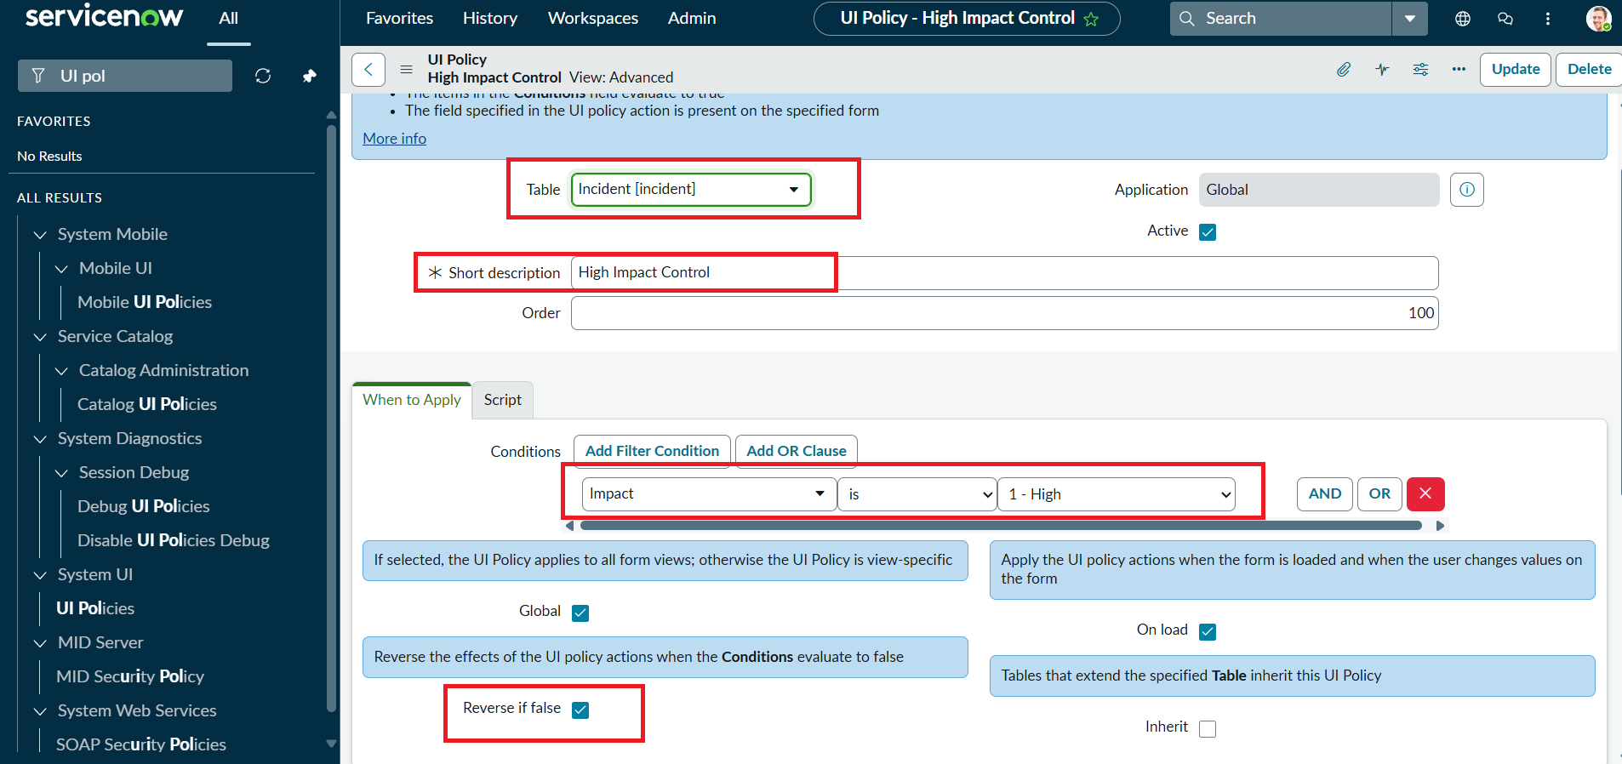
Figure 1: UI Policy configuration (Incident, Impact is 1 - High, Reverse if false)
UI Policy Action on Assignment group: Mandatory = True, Read only = False.
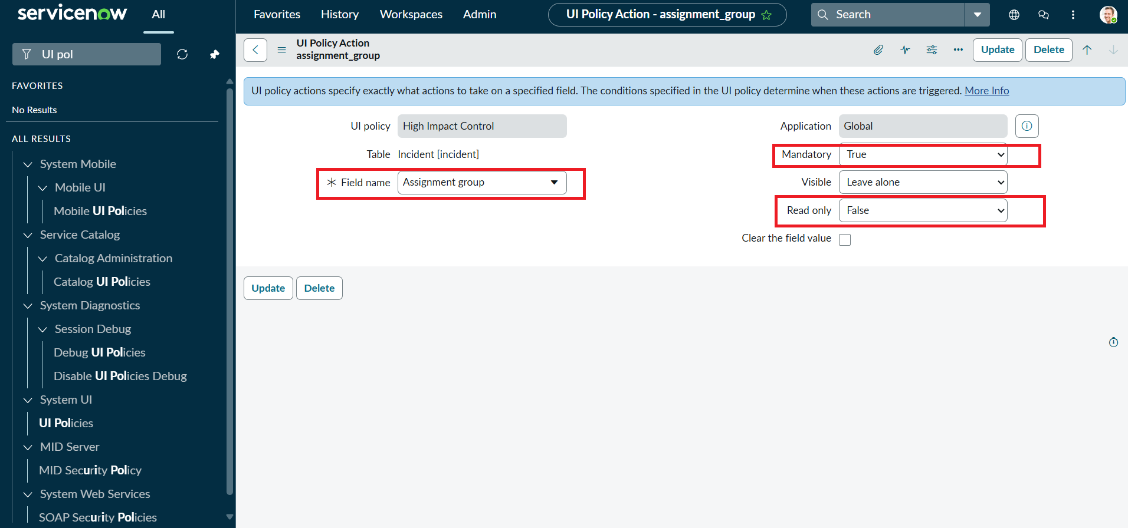
Figure 2: UI Policy Action - Assignment group mandatory

Task 2: UI Policy Action - Urgency
Urgency is read-only whenever Impact is High; Visible is left unchanged.
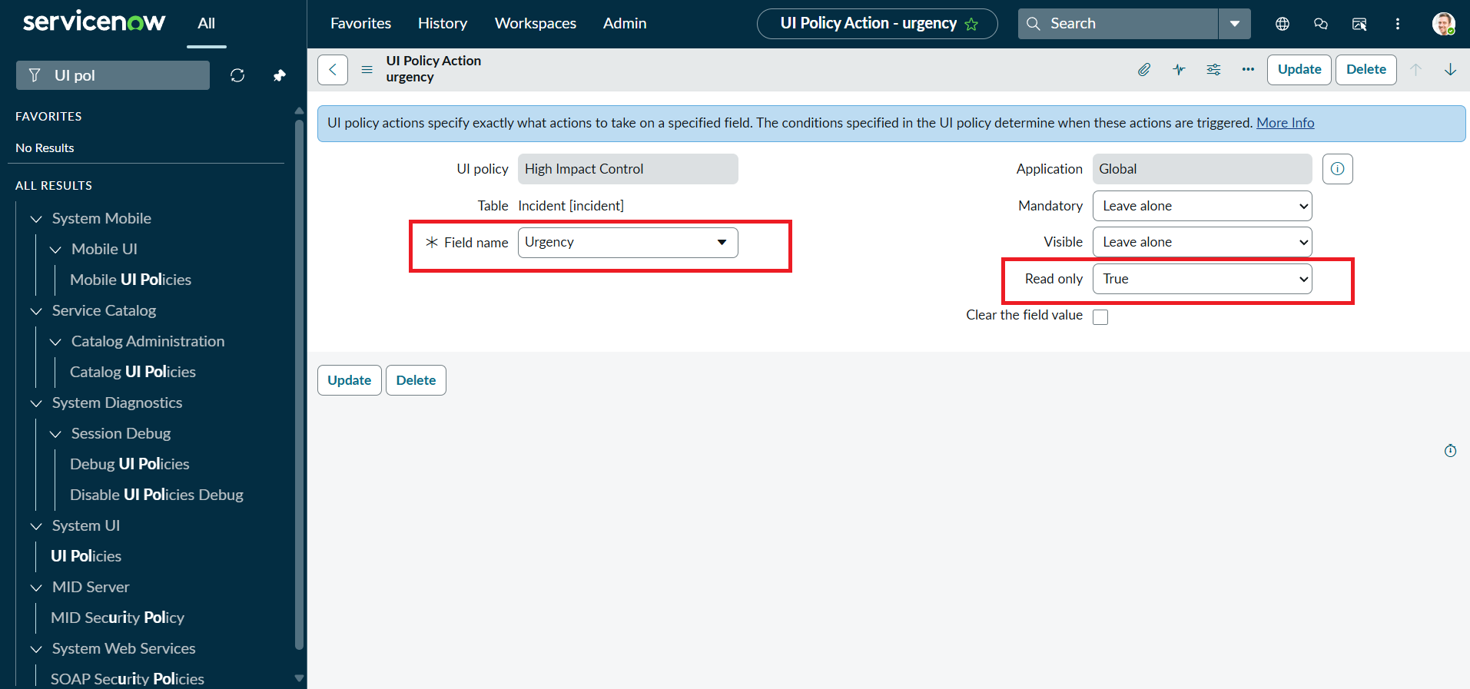
Figure 3: UI Policy Action - Urgency read-only

Task 3: onChange Client Script - Auto set urgency for high impact
Type onChange, Field name Impact, Table Incident. Script as specified in the project instructions:
function onChange(control, oldValue, newValue, isLoading) {
if (isLoading || newValue == '') {
return;
}
if (newValue == '1') {
g_form.setValue('urgency', '1');
g_form.addInfoMessage('Urgency set to High for High impact incident.');
}
}
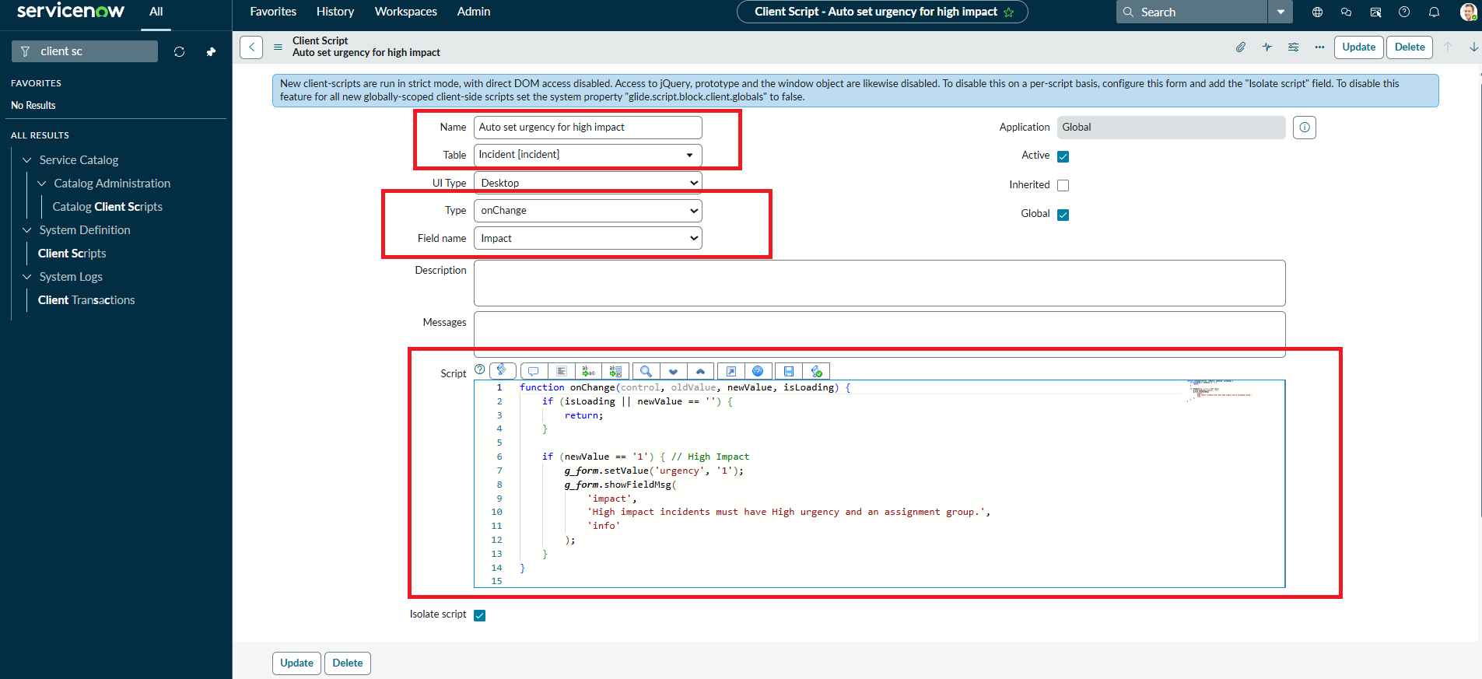
Figure 4: onChange Client Script configuration

Task 4: onSubmit Client Script - Prevent save if Assigned To missing
function onSubmit() {
if (g_form.getValue('impact') == '1' &&
g_form.getValue('assigned_to') == '') {
g_form.showErrorBox(
'assigned_to',
'Assigned To is mandatory for High impact incidents.'
);
return false;
}
return true;
}
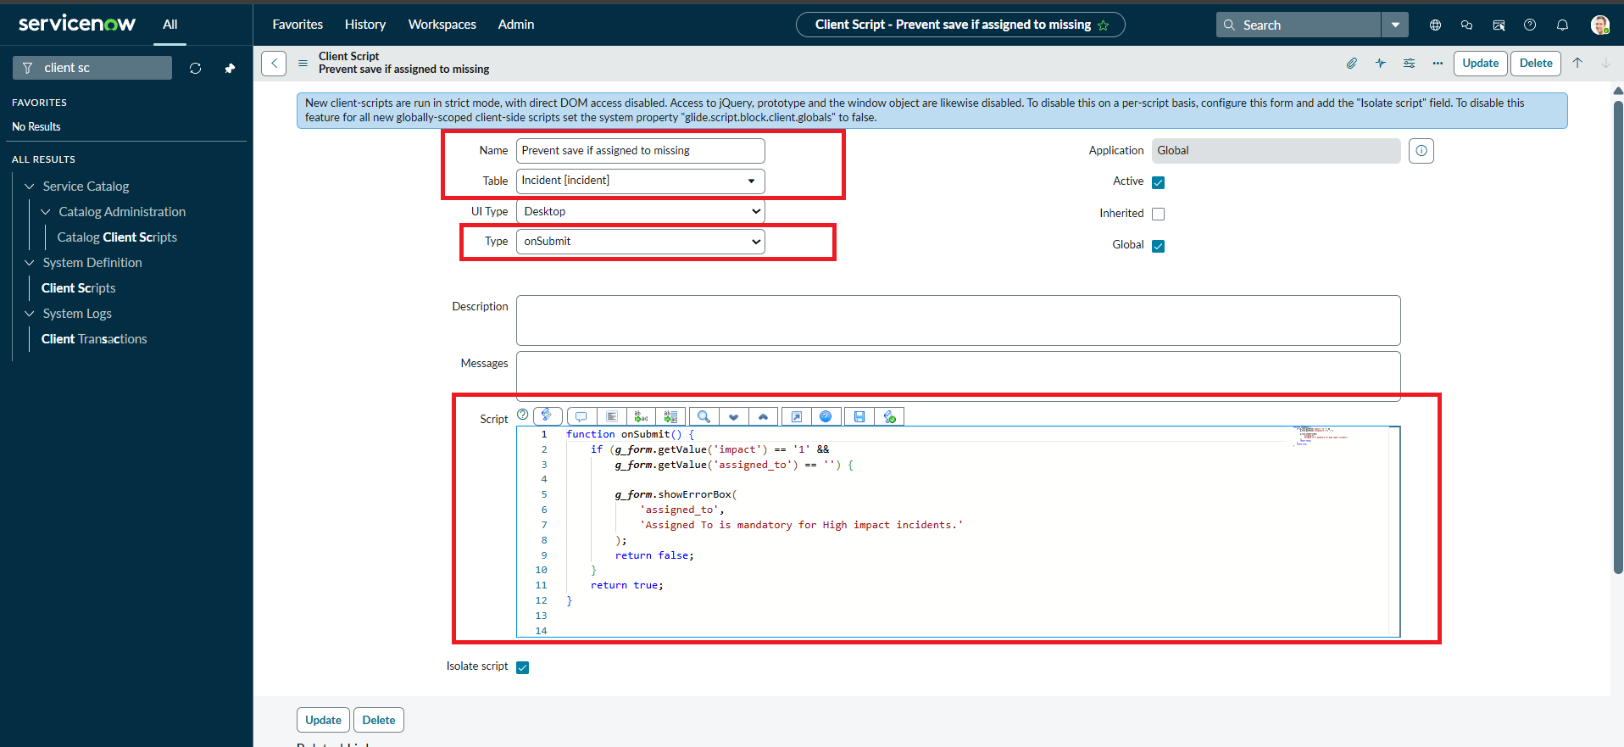
Figure 5: onSubmit Client Script configuration

Task 5: onCellEdit Client Script - Prevent state change via list edit
function onCellEdit(sysIDs, table, oldValues, newValue, callback) {
alert('State cannot be updated using list editing. Please open the Incident.');
callback(false);
}
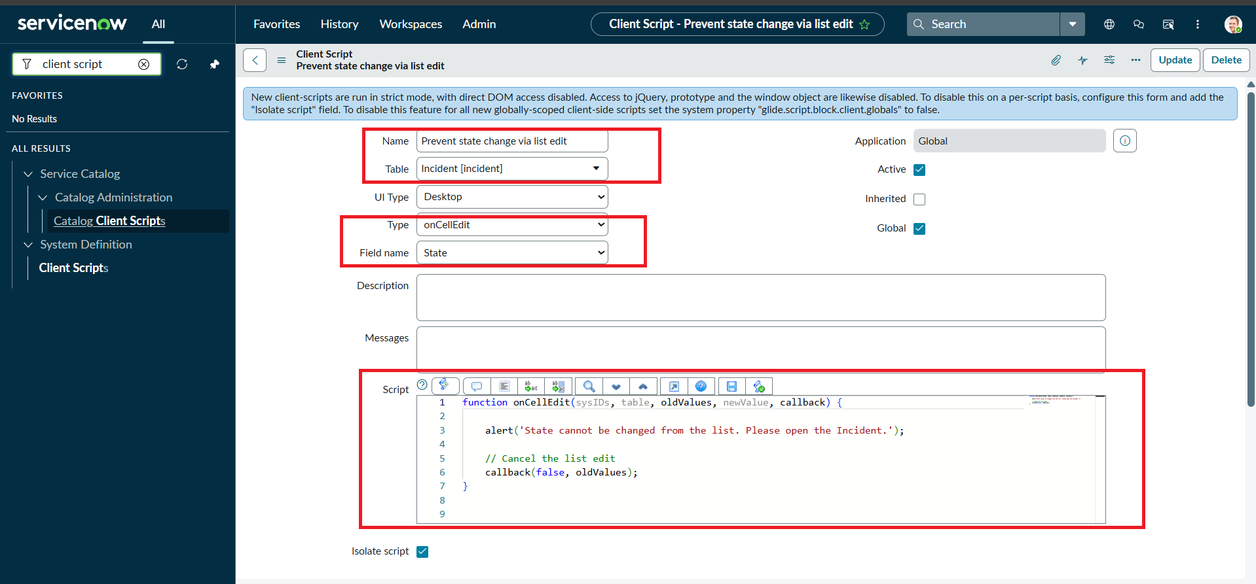
Figure 6: onCellEdit Client Script configuration (Field name: State)

Task 6: Testing the Configuration
Activity 1 - Mandatory enforcement: Impact set to High and Assigned To left empty. Submit is blocked and an error appears under Assigned To.
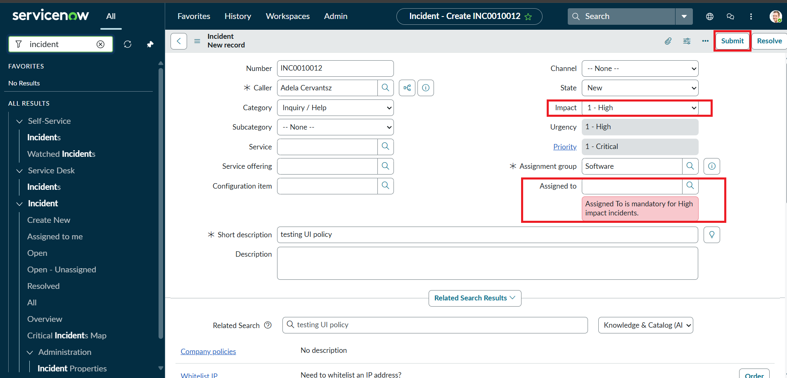
Figure 7: Save blocked with error message on Assigned To
Activity 2 - Successful save: with Assigned To filled, the Incident saves; Urgency is 1 - High and read-only.
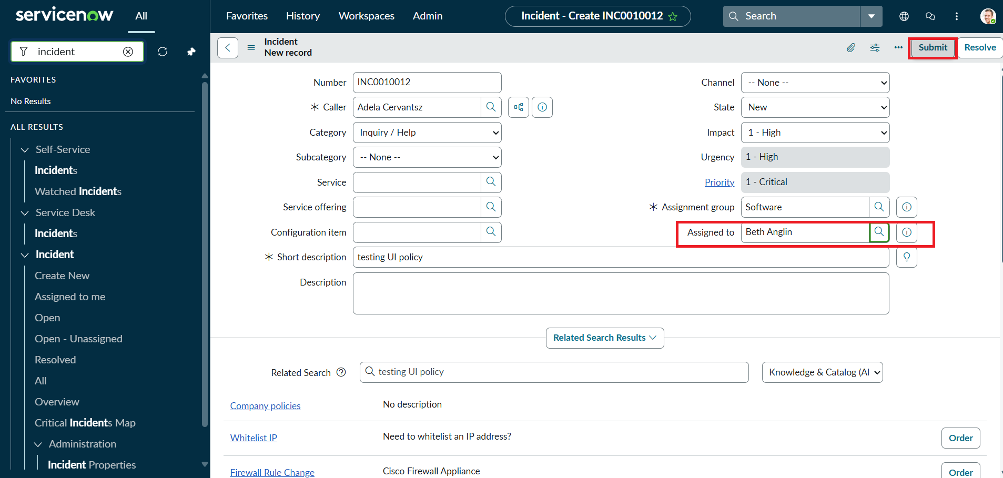
Figure 8: Incident with Assigned To populated, Urgency read-only
Activity 3 - Reverse condition: Impact changed to 2 - Medium; Assigned To is no longer required.
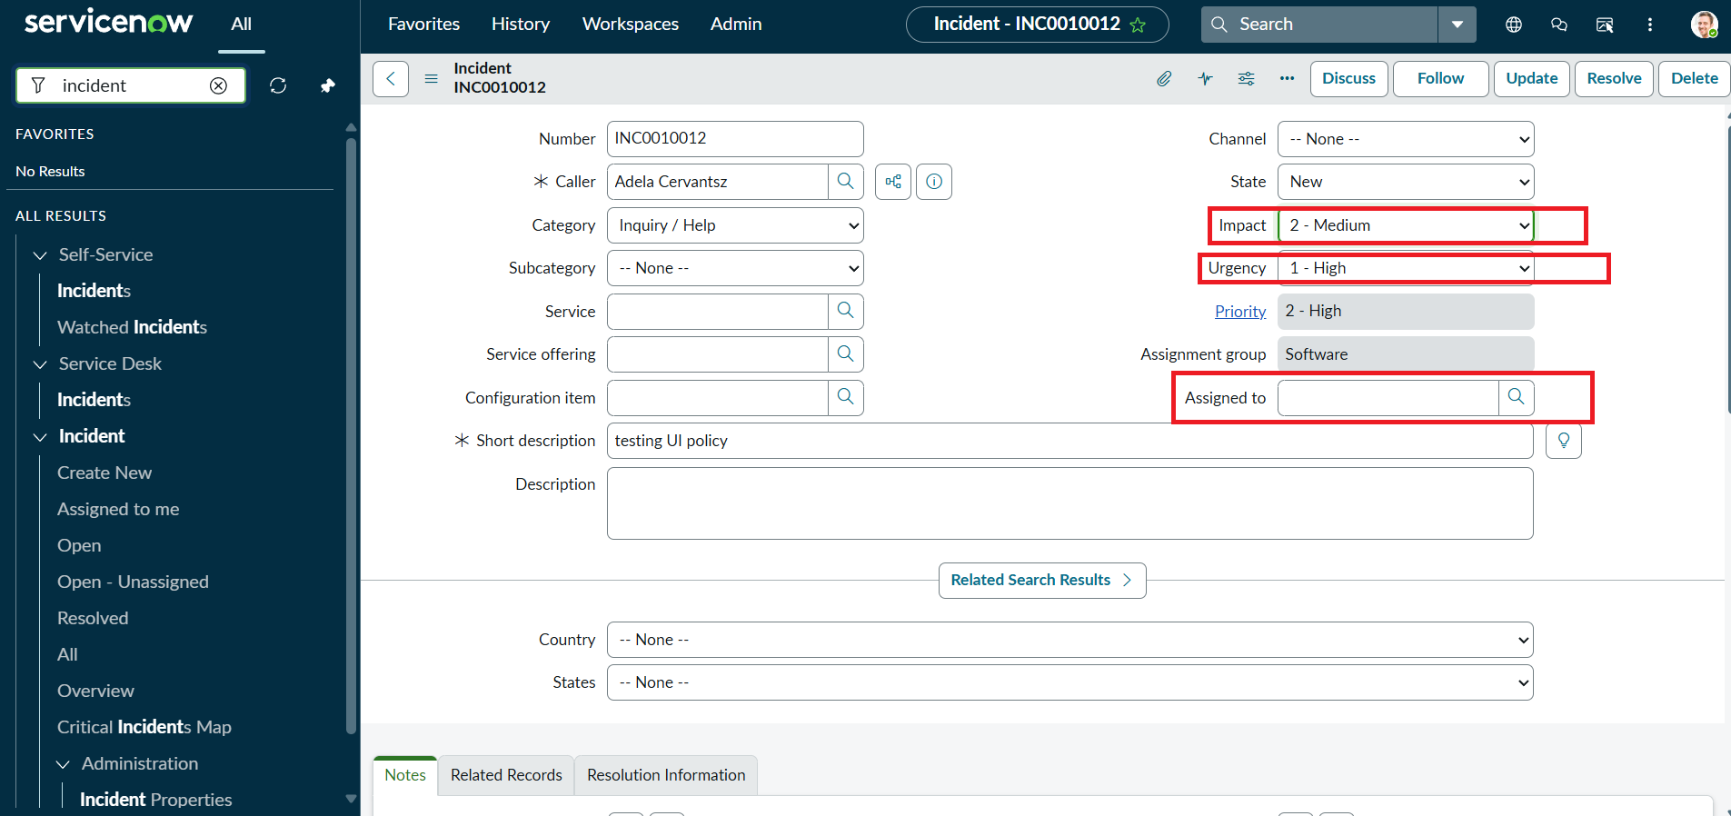
Figure 9: Reverse-if-false behaviour after changing Impact to Medium
Activity 4 - List edit blocking: editing State from the list shows an alert and leaves the value unchanged.
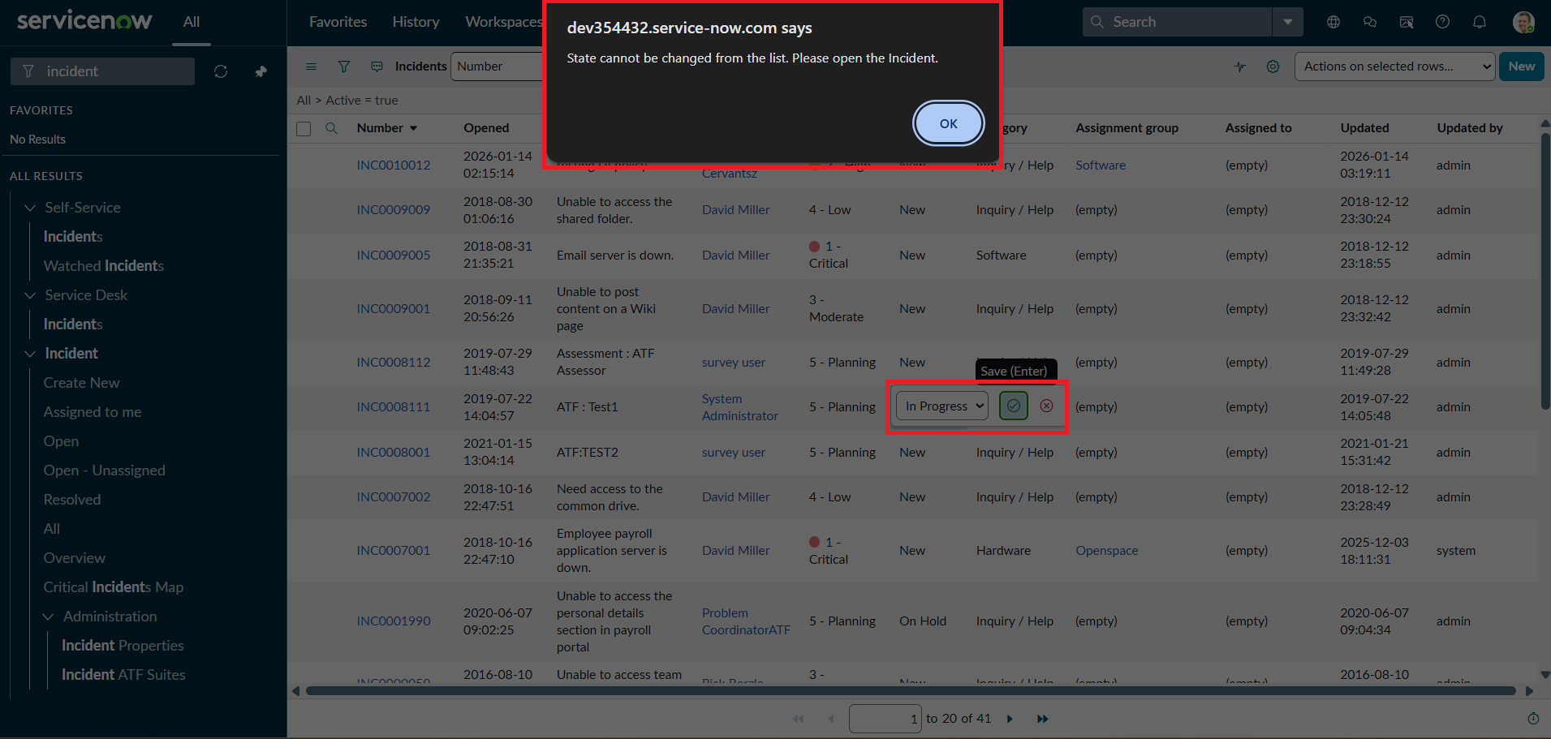
Figure 10: Alert shown when editing State in list view
Activity 5 - Form-based update: State changed to In Progress on the form and saved successfully.
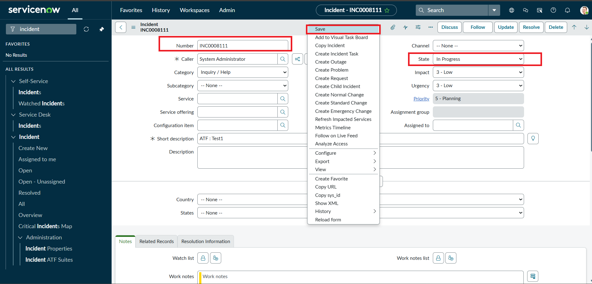
Figure 11: State updated on the Incident form
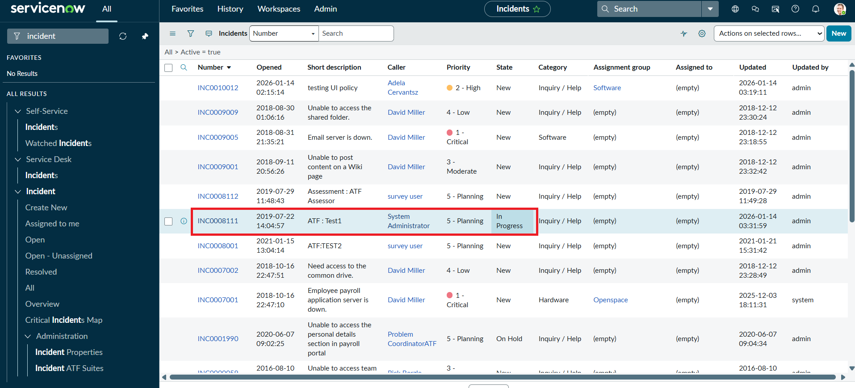
Figure 12: Incident list showing the updated State (In Progress)

8. Advantages & Disadvantages
Advantages
- Immediate feedback to the user before the record is saved.
- Improves data quality and consistency; supports SLA compliance and reporting.
- Low-code and lightweight; no server-side customisation needed.
- Reverse-if-false keeps the form clean when the condition no longer applies.
Disadvantages
- Client-side controls can be bypassed by imports, integrations or APIs; server-side Business Rules or Data Policies are needed for full enforcement.
- The onCellEdit script blocks every list edit of State, including legitimate ones.
- Urgency set by the script is not reverted automatically when Impact changes back (as seen in the reverse test).
- Hard-coded values (for example impact = 1) need maintenance if choice values change.

9. Conclusion
The project shows how UI Policies and Client Scripts work together to enforce dynamic field behaviour, automate updates and prevent incorrect data submission on Incident forms. With onChange, onSubmit and onCellEdit scripts alongside UI Policy actions, fields such as Assigned To, Assignment group and Urgency respond correctly to changes in Impact, keeping data clean and consistent. The solution is lightweight, easy to implement and a practical example of improving form usability and data integrity in ServiceNow.

10. Future Scope
- Add a server-side Business Rule or Data Policy so the same rules apply to imports and API calls.
- Restore Urgency to its previous value when Impact moves away from High.
- Allow role-based exceptions to the list-edit block (for example, admins or specific groups).
- Extend the pattern to Priority, Category or other tables (Problem, Change).
- Package the configuration in an update set or scoped application for reuse.

11. Appendix
- Source Code: Client Script and UI Policy configuration are shown in Section 7.
- Dataset Link: Not applicable (uses the Incident table of the ServiceNow instance).
- GitHub & Project Demo Link: [Add your GitHub / demo link here]

